 |  | Place name  is where born |  |  | Mary Ann ??  1806- | John Thurlow  1801-
 |  |  |  |  |  | ↓
 |  | Thomas Whittaker  ??-?? | Joseph Blake ? | Mary Blake  ??-?? | Emma Winter  1841-??  Clerkenwell  Middx  (London) | Charles Thurlow  1841-  Clerkenwell  Middx  (London) | Carl E Schneider  ??-??
 |  | ↓ |  | ↓ | ↓ |  | ↓
 |  | Mabel M E Whittaker  1886-1977? | m  8 June 1903  Kolar Gold Fields | John Blake  1873-  after 1914 ??  Ennystown  C. Clare  Ireland | William Thurlow  1871-??  Clerkenwell  Middx  (London) | m  1902 | Anna D M Schneider  pre1881-??
 |  | 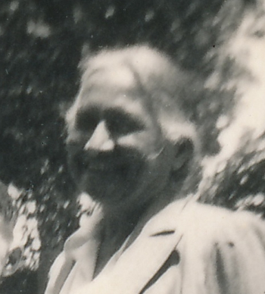 |  |  |  |  | 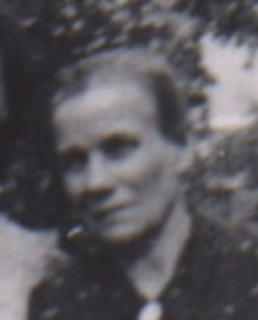
 |  |  |  | ↓ |  | ↓
Thomas Blake | Curzon Blake | Bernard Thomas Blake [Barnie] b. 17 Jan 1907  bpt 12 Feb 1907 | Norah Mildred Blake, b 27 Jul 1905  bpt 20 Aug 1905 | Patrick G Blake  1904-  Nandiroog  Kolar GF | m  1940 | Anna D Maud  Thurlow  1909-  Baroda Camp | Willie Thurlow  24.12.1903 | Alfred Thurlow  6.07.1905 | Frederick Thurlow  29.10.1906 | Louise Thorlow
 | 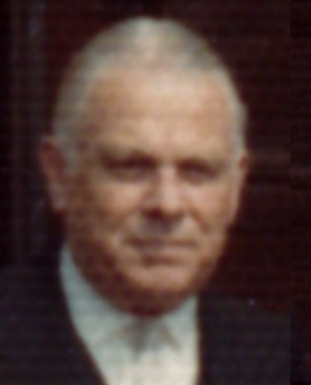 | 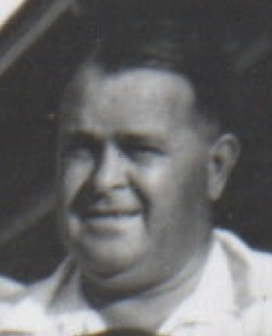 | 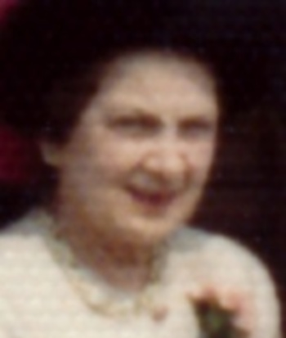 | 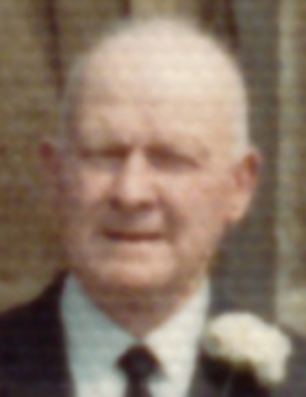 |  | 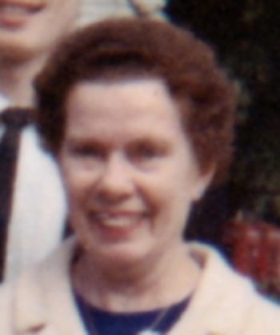 | 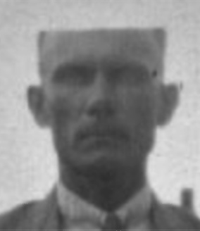 | 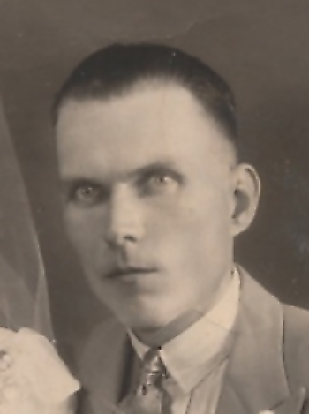 | 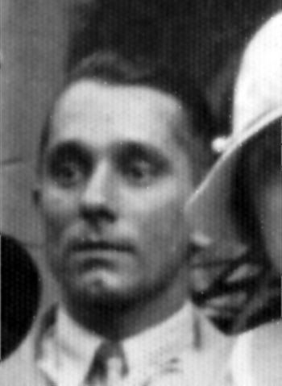 | 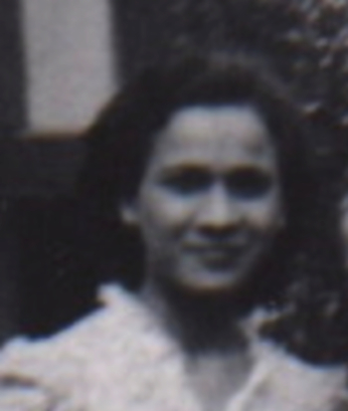
 |  |  |  |  | ↓
 |  |  |  | Lynnette P Blake  1941-  Karachi | Winston P Blake  1943-  Karachi | Arleen Blake  1947-  Bombay

